A social documentary is the account of the world looks like, with a social and/or environmental focus. It usually captures or conveys social issues, human experiences, and community realities through photography, film, or another form of media.

Concerned photography are pictures that are used to educate and change the world and not just to record it.

Compassionate photography consists of photos that trigger a compassionate attitude or mindset within a person, feeling the desire to help/make the world better.

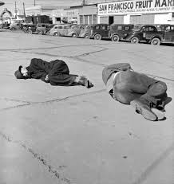

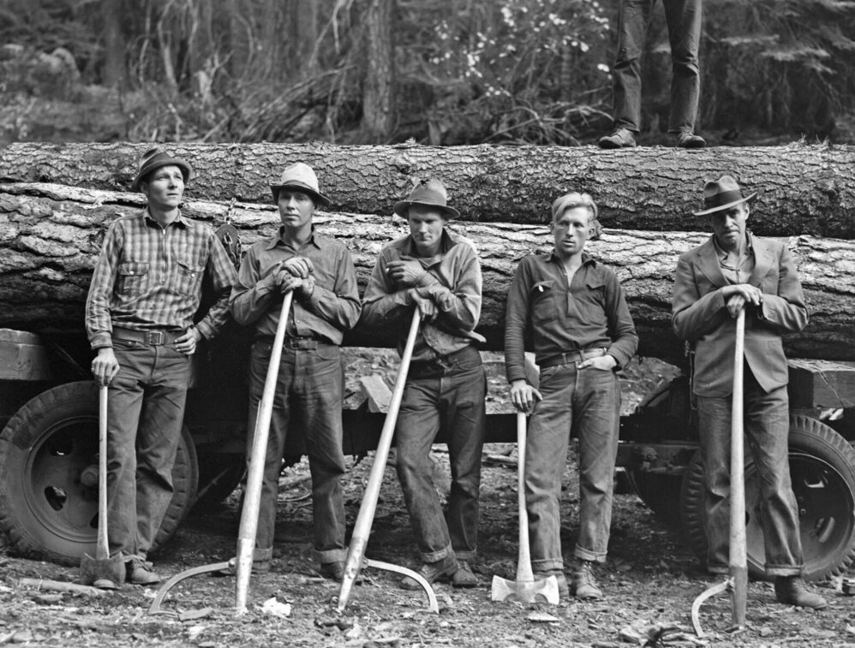

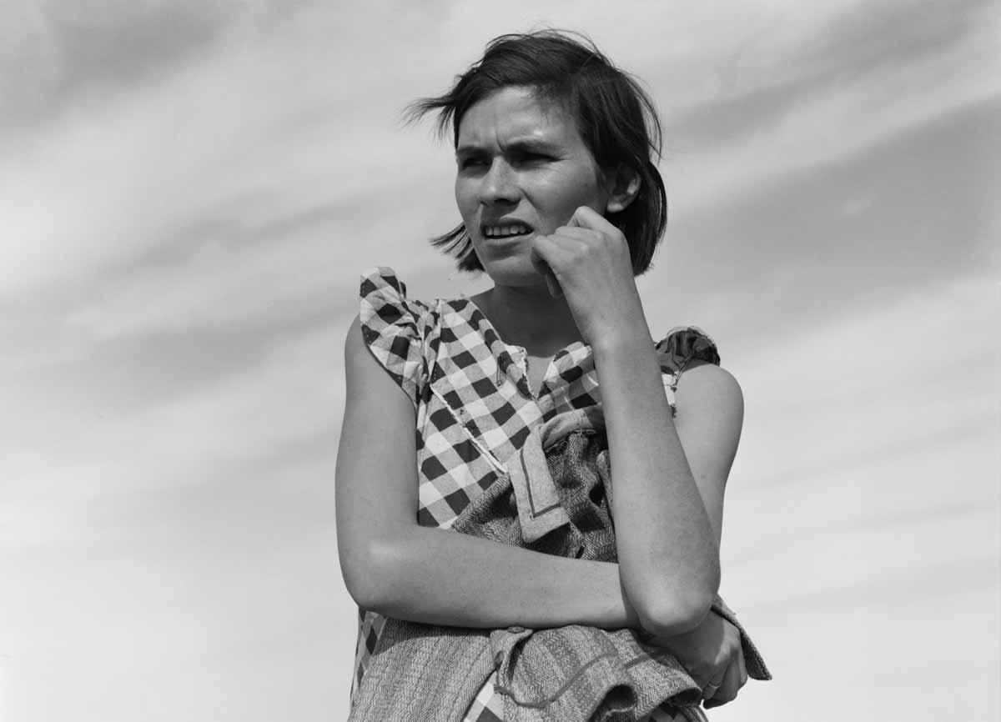

Dorothea Lange was known for her Depression-era work for the Farm Security Administration. She wanted to capture the challenges of economic depression. She pursued a career that required constant motion/travel even though she had lifelong challenges with her leg and hip. Lange’s mages of desperately poor families told the stories of those who had been unfortunate.